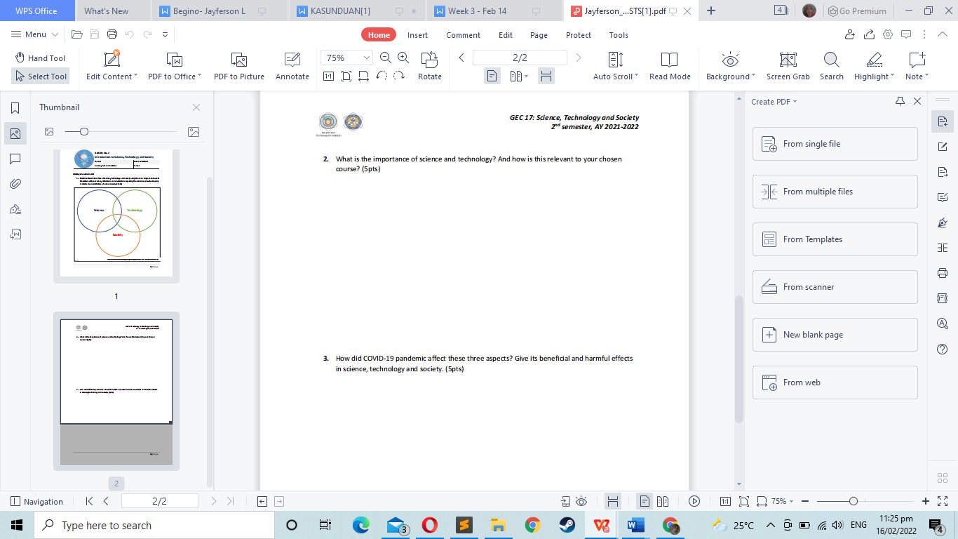

COVID-19 greatly affect these three aspects. It make people closer to technologies which is good and bad. It is good because people will gain more knowledge about it and will give them jobs regarding to technologies. The bad thing is since its pandemic, most children will be using technologies such as phones or computers to spend their time on it since they cannot go outside to play and it will result to addiction and internet is the most dangerous place and they might learn bad things from it and do those bad things to others.

As for its benefits I don’t see it beneficial to society. I see it beneficial to science and technology because it will help them learn new things like vaccines etc. through this, technologies will be in used.

It helps our lives easier by making technologies that will help us on our daily deeds. Without science, there will be no technologies. Because of science, technologies were made. Science builds ideas while technologies are the result of these.

Science and technology is very relevant to my chosen course (IT) since my course is about technology. It will help me understand how certain technology works.

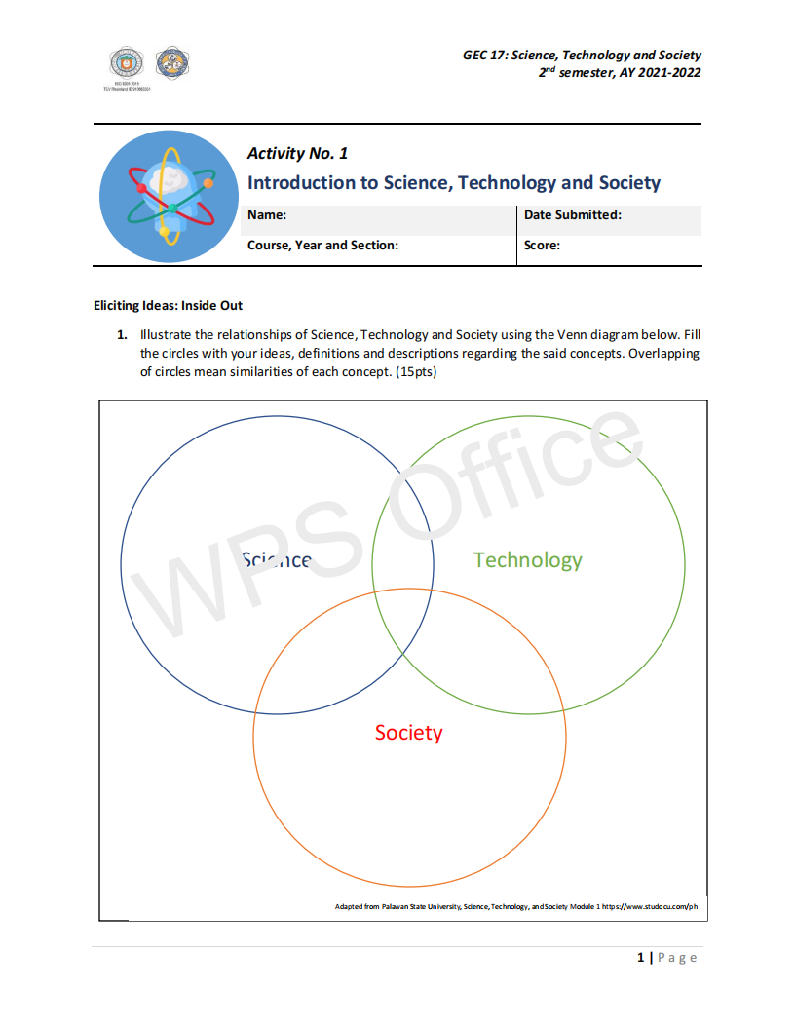

Helps human development

Where science and technology develops and are being used

Is everywhere

Machineries

Description

Identification

Product of science

Experimental Investigation

Observation, Identification, Description